World News Hub

By

Manpreet Kaur

Level-6

Final Project

Table of Contents

Project Proposal 3

Goals and Objectives 3

Project Scope 3

Project Specifications 3

Target Audience 3

Project Deliverables 4

Resource Requirements 4

Project Tasks and Milestones 4

Project Assumptions 5

Project Report 5

Non- Functional 6

Detail Design 6

Home Page 6

News Page 6

World News Admin View 7

Reporter Page Admin View 8

Reporter Registration Page 9

World News Reporter View 9

Project Testing 10

User Manual 11

Summary 11

System Configuration 11

User Access Levels 11

# 

# Project Proposal

## Goals and Objectives

This project aims to implement an online web application named “World News Hub”. With the help of this application one can view international news and events on their fingertips. This application consists of an admin and reporter. Both of them are having their valid credentials to login. The roles and permissions of both vary. Admin can edit, delete, and check details of news, admin can also create, edit, delete, and check details of various reporters. Moreover, reporters can add new articles, edit, delete, and check details for the world news. Admin can register new admins and new reports can register with the web application.

## Project Scope

The duration of the project is 20 working days which equals to 4 weeks. The scope of this project is to implement an app named “World News Hub” with the help of which users can read any news on their fingertips.

## Project Specifications

* Login by admin and reporters
* Edit, delete and check details of news by admin
* Admin can create, edit, delete and check details of the reporters
* Admin can register new admins.
* Reporters can add new articles, edit, delete and check details
* New Reporters can register themselves.

## Target Audience

The audience for this project is the people who are keen to know what is happening in their surroundings. The age can be from 18 years to maximum can go 100 plus or more.

## Project Deliverables

The deliverables of the project are:

|  |  |
| --- | --- |
| **Deliverable** | **Description** |
| Final Report | This is the final report |
| Coding | The coding will go into this. The executable code of the project. |
| Documentation | This depicts the documentation of the project. |
| Testing | All the test details will be covered in this part. |

## Resource Requirements

The technologies used in this project are as follows:

* Asp.net MVC Framework
* 64-bit processor and 4 GB or more RAM
* Identity framework- ASP
* Windows Operating System
* Microsoft word for documentation.

## Project Tasks and Milestones

The table below shows the Project Tasks and Milestones

|  |  |
| --- | --- |
| **Tasks** | **Weeks** |
| Research and analysis | 1-2 |
| Planning and first kick-off meeting Project Proposal document. | 1-2 |
| Design of Database | 2-3 |
| UI design | 2-3 |
| Identity framework implementation | 2-3 |
| Coding for admin and reporter | 3-4 |
| Testing | 3-4 |
| Final Documentation | 3-4 |

## Project Assumptions

While doing the implementation, the following are the assumption made:

* One admin and reporter will be there to login when the app will be designed and implemented.
* Admin can only register new admin if he/she will be signing first.
* App will be free
* The app will be user-friendly and cost-effective.

# Project Report

#### Functional and Non-Functional

The functional requirements and non-functional requirements of this project are as follows:

|  |  |  |
| --- | --- | --- |
| Users | Functional | |
| Admin | * Manage reporters, add, edit, delete, and check details. * Login * Register new admins * Edit, delete, and check the details of the news. | |
| Reporters | * Add, edit, delete, and check details for the articles. * New reporters can signup * Login using valid credentials | |
|  |  | |
| Non- Functional | | |
| * The project will be compatible with all browsers and devices. * Security * Fast load time of the project. * High performance * Limited access for the reporters. | | |

## Detail Design

### Home Page

This page is the main landing page of the application. On this page on the navigation menu there are options- news, reporter registration, login, and register site admin. Moreover a button view news is also present in the header images, which when clicked shows the news around the world.



### News Page

This page highlights the various news available around the world. Users can click on read more button to read the news in more detail.

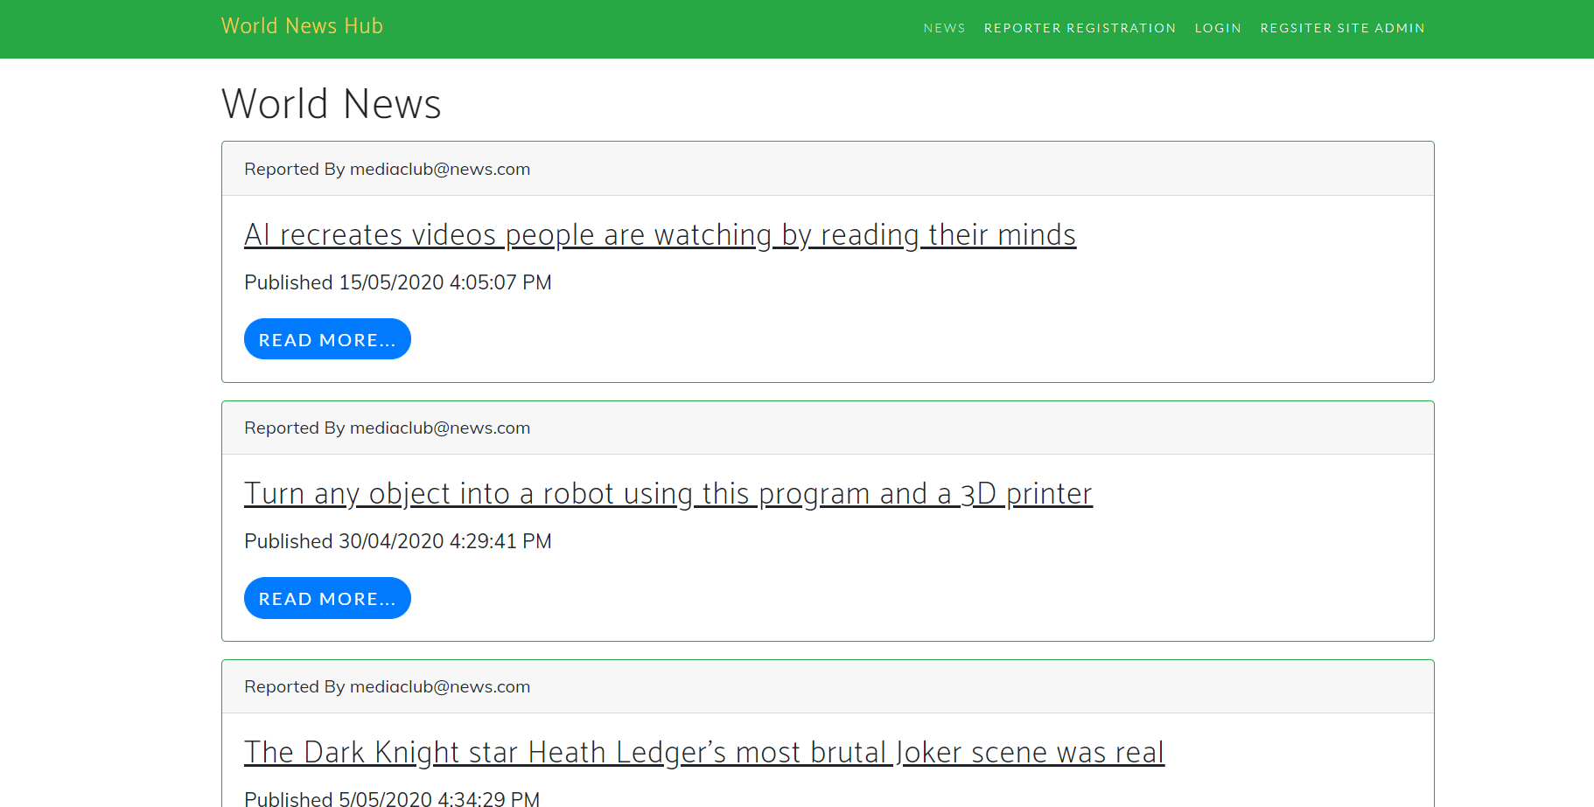

### World News Admin View

This page shows the admin view of the world news, admin has the right to edit, delete, and check the details of the various news available on the web application.

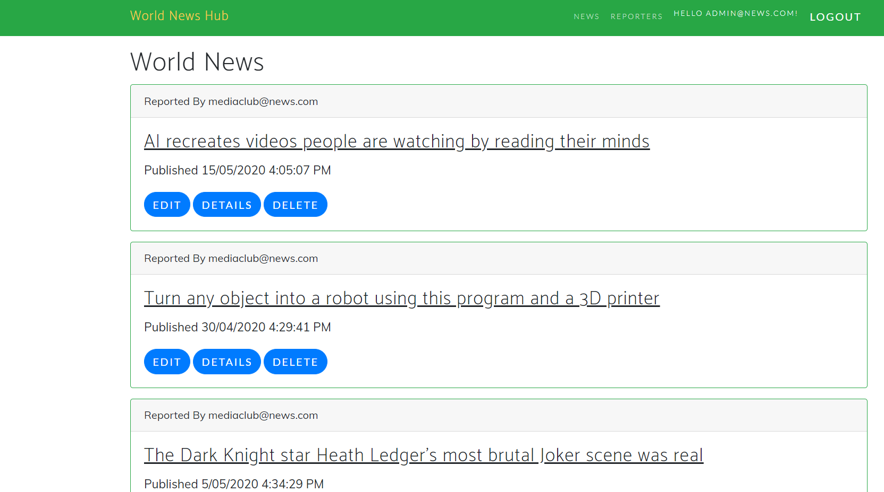

### Reporter Page Admin View

This page shows the various reporters available on the app. Admin has the right to create new reporters. Manage the existing ones by editing, deleting, and checking their details. This page is showing the admin view of the reporter page.

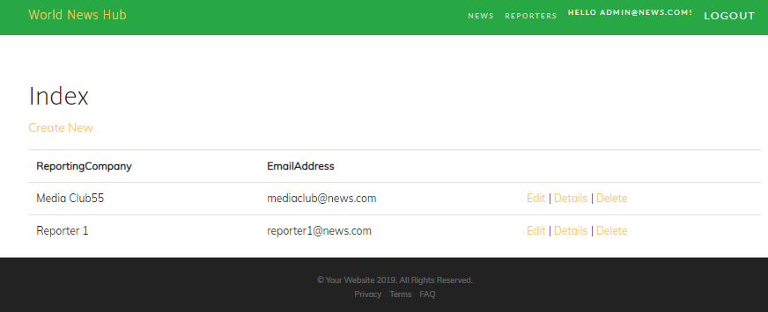

### Reporter Registration Page

This page shows the fields which a reporter needs to fill to register him/her with the world news hub app.

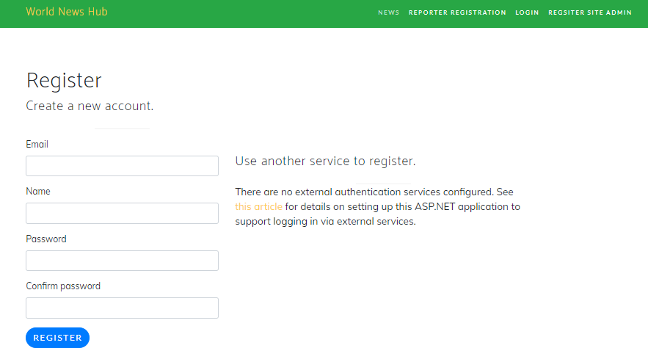

### World News Reporter View

This page shows the reporter view of the world news page. As a reporter one can add new articles to the app. Also, I can edit, delete, and check details of the various articles.

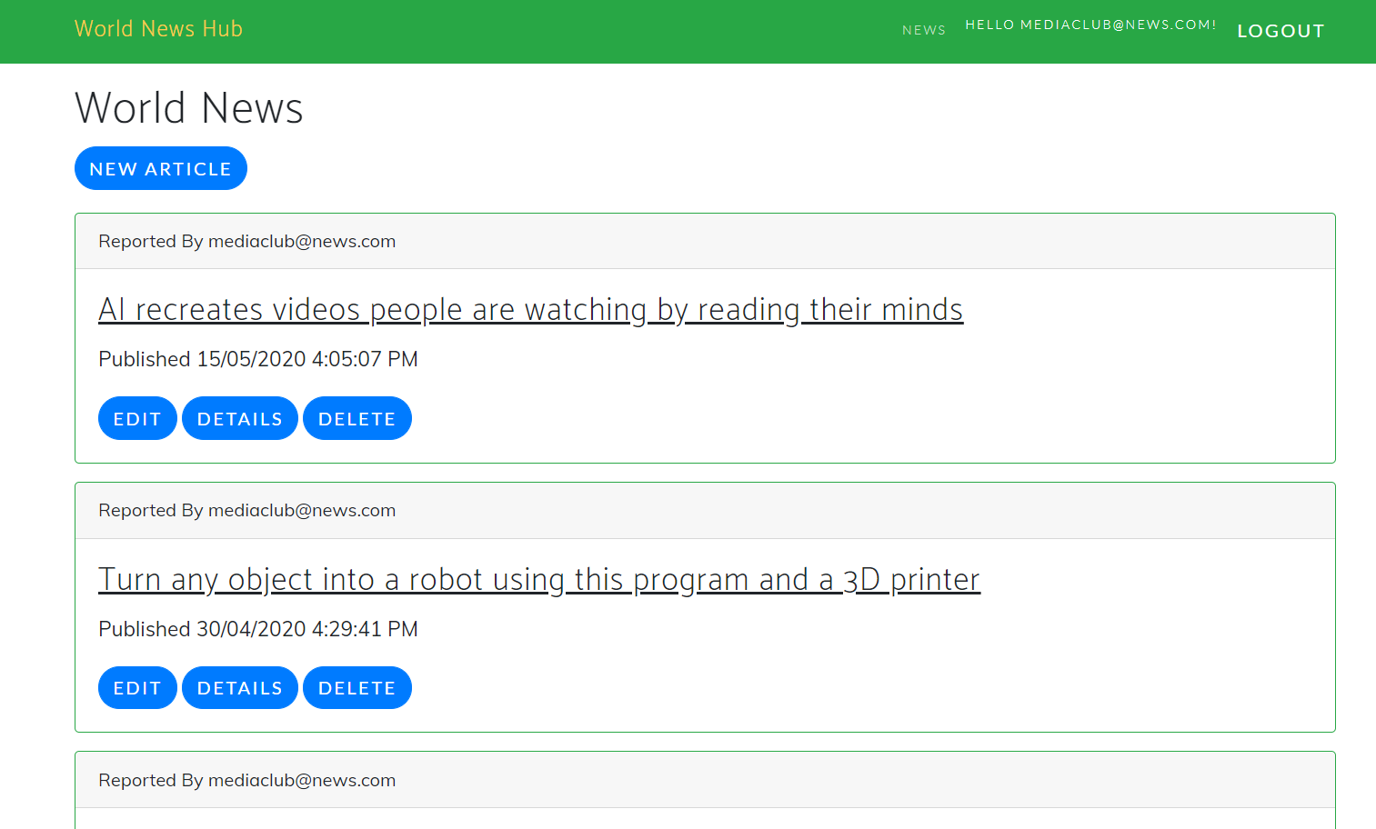

## Project Testing

Excel File Attached for Usability Testing [Usability Testing.xls](Usability%20Testing.xls)

# User Manual

With the help of “World News Hub” one can view international news and events on their fingertips. This application consists of an admin and reporter. Both of them are having their valid credentials to login. The roles and permissions of both vary. Admin can edit, delete, and check details of news, admin can also create, edit, delete, and check details of various reporters. Moreover, reporters can add new articles, edit, delete, and check details for the world news. Admin can register new admins and new reports can register with the web application.

## Summary

### System Configuration

World News Hub app will be useful to find what is happening around the world. One can access the news with their fingertips.

### User Access Levels

Only registered users can access the features of the Job Advertisement application

* **Admin:** Admin has full access to the app can register new admins.
* **Reporters:** All reporters are having limited access and all reporters are managed by the admin. New reporters can register themselves.